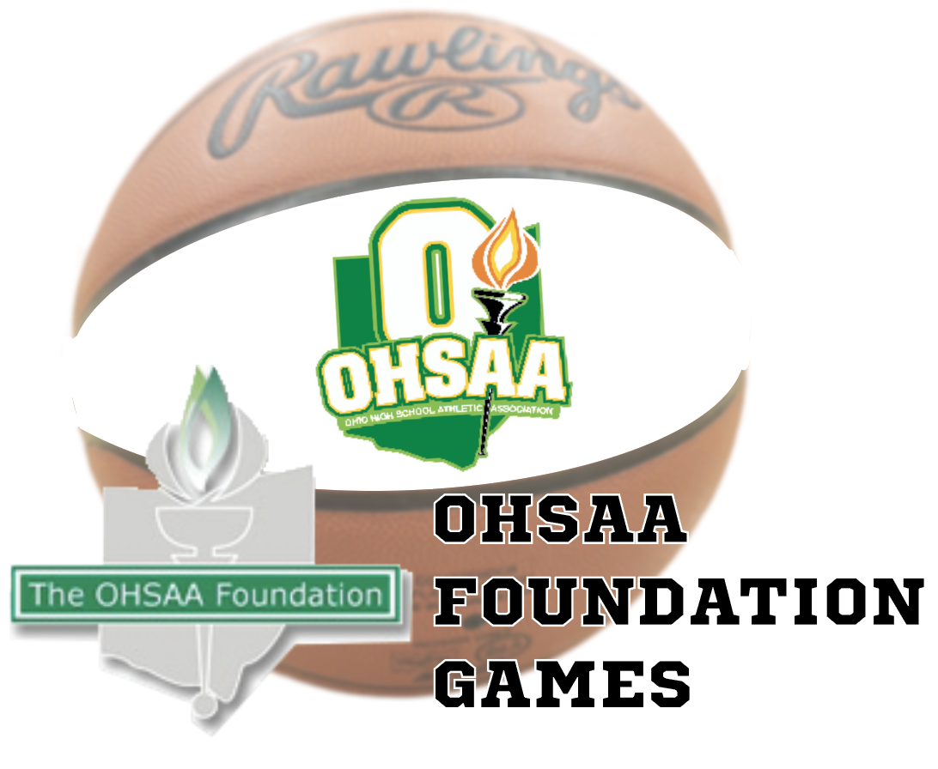
2022-23 Foundation Service Week

Post-Event Report

The host school (or facilitator) is required to submit a completed post-event report for each Foundation Game. If the visiting school selected a service project different than the host school, the visiting school is also required to submit a post-event report regarding their service activities. Please complete all portions of the form and attach additional pages as needed.

Game Background Information

Host School:
Opponent:
Foundation Game Date: |  | Participating Teams: | Boys Girls Both
Game Times (all games - JV, etc.): |  | Final Admission Price(s):
Total Attendance: |  | Paid Attendance:

Person Submitting Report: |  | Email Address:
Title: |  | School:

Financials

1. | Total Funds Raised for Selected Charities: | $
2. | How did you raise funds for your selected charities (ticket sales, other revenue sources, etc.)?
3. | Did any game personnel donate their time so that additional monies could be donated to the selected charities? Did any game personnel made additional contributions?
4. | Did you secure a local sponsor to cover the contribution to the OHSAA Foundation on your behalf? If so, who? Please provide details regarding any sponsor involvement.
5. | Each participating school is required to make a $250 contribution (per school, per event) to the OHSAA Foundation. Is the appropriate contribution for your event enclosed? All checks should be made payable to the “OHSAA Foundation.” |  | Yes  (contribution is enclosed) | No  (contribution has already been submitted) | No  (contribution will be mailed separately – see below)
 | If your contribution is being sent separately from the post-event report, please tell us who is sending the check(s) (i.e. school, sponsor, booster club, etc.).

Service Project(s)

Please provide detailed information regarding the service project(s) selected by you and your opponent for Service Week. We would like to hear about the activities the students took part in for Foundation Service Week. Attach additional sheets as needed.

Selected Charity (Charities):

Please describe your service activities:

Please attach copies of any newspaper articles regarding your Foundation Game (before and after your event). If you have any photos of your Foundation Game or your service activities, please email them to Kimberlee Kiehl at the email address below.

Post-Event Reports can be downloaded at www.ohsaa.org, completed and e-mailed to kkiehl@ohsaa.org . They can also be mailed to Kimberlee Kiehl at the OHSAA Office,4080 Roselea Place, Columbus, OH 43214 or faxed to the attention of Kimberlee Kiehl at (614) 267-1677.

