OHIO HIGH SCHOOL ATHLETIC ASSOCIATION  4080 Roselea Place, Columbus, OH 43214  Phone 614-267-2502 | Fax 614-267-1677  www.OHSAA.org | Twitter.com/OHSAASports | Facebook.com/OHSAA | 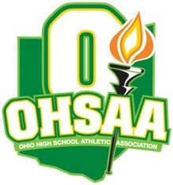

EMAIL THIS FORM TO Brenda Murray – bmurray@ohsaa.org – OR FAX TO 614-267-1677 OR BRING TO THE STATE QUALIFIERS MEETING ON TUESDAY, JUNE 1.

2021 Baseball State Tournament Media Coverage Form

School ______________________________ Division _____

The OHSAA uses this information to plan for media coverage at the softball state tournament. Media must still request credentials from Tim Stried at the OHSAA. This form does not guarantee that credentials will be granted to every outlet.

Please check-mark where appropriate:

Newspapers (name of paper/city) Regular-Season Districts Regionals
________________________ ________ _______ ______
________________________ ________ _______ ______
________________________ ________ _______ ______

Radio Stations (call letters and/or frequency/city – place an * beside those doing play-by-play)
________________________ ________ _______ ______
________________________ ________ _______ ______
________________________ ________ _______ ______

Television Stations (call letters/city)
________________________ ________ _______ ______
________________________ ________ _______ ______
________________________ ________ _______ ______

Websites with No Print Product (place an * beside those sites doing play-by-play broadcasts)
________________________ ________ _______ ______
________________________ ________ _______ ______

Name of School Photographer _____________________________________________

