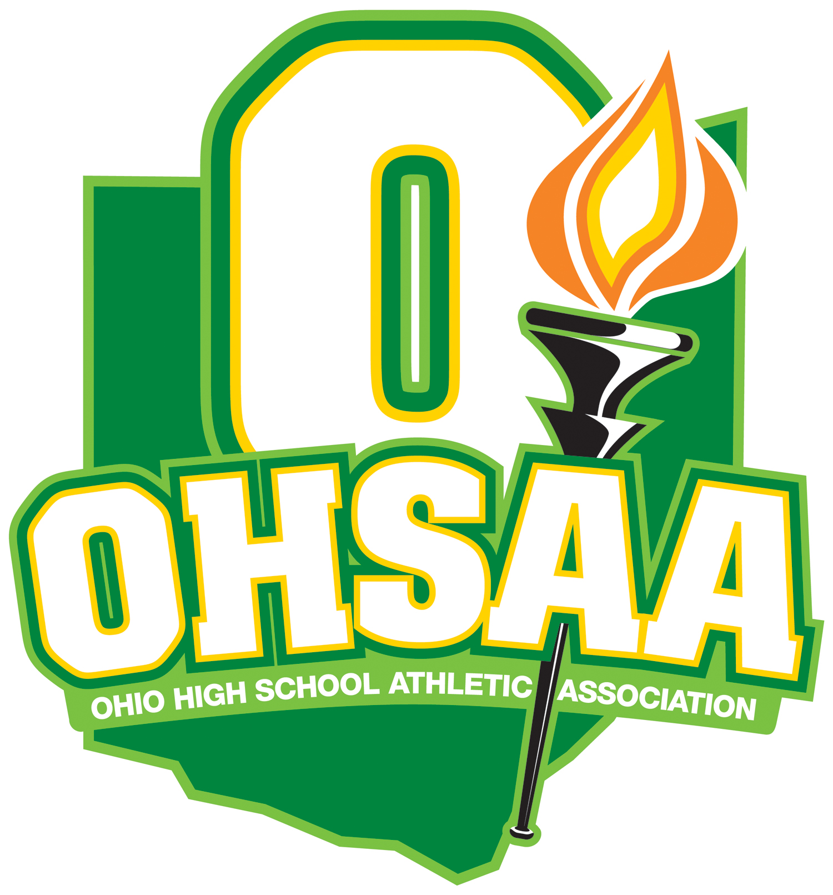

USA SWIMMING 18 & UNDER VIRTUAL CHAMPIONSHIPS NON-INTERSCHOLASTIC WAIVER
Due to the high demand of non-interscholastic waiver requests for this specific event- USA Swimming 18 & Under Virtual Championships-this form is an approved waiver from the OHSAA office for swimming athletes to participate ONLY if they have met the published time standards during the qualifying period. Those standards can be found here: https://www.usaswimming.org/times/time-standards/2020/2020-18-under-virtual-championships

Please complete the information below and return to kbarnett@ohsaa.org for OHSAA record keeping. The administrator signature attests that the student(s) has met the necessary standards. Once you have submitted this completed form to the email above, the student(s) is approved to participate. You will not receive a confirmation email in return but please feel free to keep a copy for your own files.

- Name of School:
______________________________________________________________________________
- Name of Event:
USA 18 & Under Virtual Championships (a request is required for any event other than this one)
- Names of Each Student who has Qualified by Achieving the Published Time Standards During the Qualifying Period:

_________________________________
_________________________________
_________________________________
_________________________________
_________________________________
_________________________________
_________________________________
_________________________________
_________________________________
_________________________________

- Administrator Signature: _________________________________________________
Print Name: _____________________________________ Title: __________________________________
Email: __________________________________________________ Date:__________________________

For Office Use Only: Approve

OHSAA Staff Signature: Date:

